Standard Operating Procedure (SOP) #5

Transect Generation

Version 2.0 (November 19, 2018)

Change History

|  |  |  |  |  |  |
| --- | --- | --- | --- | --- | --- |
| New Version # | Revision Date | Author | Changes Made | Reason for Change | Previous Version # |
| 2.0 | 11/19/2018 | Mark Wasser | Updated transect generation procedures and software versioning. | Reflect best practices using current software and extensions. Standardization / consistency of spatial data management across PACN. | 1.0 |
|  |  |  |  |  |  |
|  |  |  |  |  |  |
|  |  |  |  |  |  |
|  |  |  |  |  |  |

Only changes in this specific SOP will be logged here. Version numbers increase incrementally by hundredths (e.g., version 1.01, version 1.02) for minor changes. Major revisions should be designated with the next whole number (e.g., version 2.0, 3.0, 4.0). Record the previous version number, date of revision, author of the revision, changes made, and reason for the change along with the new version number.

Purpose

This SOP explains how to generate rotational transects using ArcGIS® Desktop (v 10.6.1 as of this update) for the Pacific Island Network (PACN) Established Invasive Plant Species (EIPS) Monitoring Protocol. The procedures outlined in this SOP must be performed to generate new rotational and alternate transects for each sampling frame; fixed transects do not change and therefore should not need to be generated in the future. As transect locations may be shared between this protocol, PACN Landbirds Protocol (Camp et al. 2011), and Focal Terrestrial Plant Communities Protocol (Ainsworth et al. 2011), guidelines for all three protocols should be considered when generating transects. This SOP is based on available tools for ArcGIS® used by the GIS specialist and represents one of many ways to accomplish these tasks. Once transects have been generated, SOP #9 Conducting Invasive Plant Species Surveys describes how to install contiguous plots along each transect.

*Note:* Fixed and rotational transects for the initial sampling cycle (2010-2014) were generated using ArcGIS® Desktop 9.3 and Hawth’s Tool Extension. That fixed transect generation procedure is outlined in Appendix SOP 5.a. Fixed transect generation was conducted for the initial sampling cycle and has not been updated since no new fixed transects are generated in subsequent monitoring cycles. The procedures for rotational and alternate transect generation have been updated to reflect best practices and current software. As of this update (v2.0), PACN is using ArcGIS® Desktop 10.6.1.

Procedures

Locations for sampling stations will be randomly selected within ArcMap® 10.6.1 using the criteria outlined below. Randomly selected alternative station locations will also be generated in case the initial location is unsuitable with respect to habitat type or possesses conditions that make it unsafe in which to work.

Buffers and Hazard Screening for New Transects

The first step in generating new transect locations for upcoming sampling cycles is to screen for hazards and generate buffers around all major unrepresentative features such as paved roads, boundaries, trails, etc. These buffer zones represent areas that cannot contain transect lines (procedurally it may be easier to combine all unrepresentative features into one layer before generating buffers). Buffers are created using the following criteria for exclusion:

* Areas within 3 m of roads, trails, streams, coastlines, cultural features or other unrepresentative features.
* Areas within 50 m of existing fixed sampling transects.
* Locations with a slope greater than 70% (35°).

For most parks, a buffer has already been created using the above criteria. These layers can be found in the EIPS feature dataset of the PACN SDE database (located here). If using an existing buffer layer, always verify accuracy before using.

If a buffer around unrepresentative features does not exist and cannot be easily generated, individual points may be evaluated after generation by performing the following steps:

1. Based on the highest resolution digital elevation model (DEM) available, create a slope raster using the “Surface Tools” in Spatial Analyst. If a slope raster already exists in the I&M GIS database, this step may be skipped.
2. Run the “Extract Values to Points” tool located within the “Extraction” subfolder of the Spatial Analyst Toolset. This tool uses the slope raster to compute slope for each point.
3. Based on the interpolated slope values, discard all points that do not meet the slope criteria. Furthermore, if a plot location lies next to dangerous slopes that could fall within or on the edge of plot boundaries, eliminate this point as well. In general, only the wet forests of KALA, NPSA, and HALE have large areas with slopes greater than 70%. In the other sampling frames, extreme slopes are distributed more sparsely (if at all) across the frame.

New Transect Generation

Once buffers have been established and hazards screened, transects are generated randomly using the Create Random Points Tool within ArcToolbox. The criteria for transect establishment is similar to the PACN Landbirds Protocol (Camp et al. 2011) and Focal Terrestrial Plant Community Protocol (Ainsworth et al. 2011), enabling the GIS specialist to create one set of transects for all protocols where applicable. The procedure to create new transects is as follows:

1. Open ArcMap®, and load the necessary park specific project files and relevant associated layers (see above section *Buffer and Hazard Screening for New Transects*).
2. Generate points for transect origins, using the following procedure.

* Open the “Create Random Points” Tool from either ArcToolbox (Data Management Tools 🡪 Sampling) or the Search function (Fig. 1).
* Set Output Location and Output Point Feature Class to a temp directory & name.
* Select the Constraining Feature Class. This will most likely be a polygon created from the sampling frame with buffer areas excluded. If buffer areas have not been created, select the sampling frame polygon as the Constraining Feature Class.
* Enter the desired number of points to be generated in the Long field under Number of Points [value or field]. Generate extra plot points for alternate transect locations, plus any rotational locations that are rejected during point generation (see Appendix SOP 5.a – Table SOP 5.a.1 for the number of rotational plots needed for each sampling frame).
* Set the Linear Unit field under Minimum Allowed Distance [value or field] to 50 meters (if using polygon with all buffers already excluded).
* Do *not* check the box for Create Multipoint Output.
* Run the tool. The output generated is the random points.

1. Populate the newly created random point shapefile. Create, name and populate the following fields in the attribute table as follows:

* Unit_Code (Text, 5 characters long); fill in as appropriate
* Samp_Year (Short integer); fill in as appropriate (YYYY format)
* Samp_Frame (Text, 25 long); populate as appropriate
* Zone (Text, 25 long); populate as appropriate
* Trans_Num (Text, 5 long); populate in future steps
* Trans_Type (Text, 15 long); populate in future steps
* Placement (Text, 10 long); populate generated points as “Start”
* Length_m (Short integer); populate as appropriate (see Table SOP 5.a.1 for transect lengths for each sampling frame)
* Azimuth (Short integer); populate in future steps
* Longitude (Double); calculate geometry in GCS: WGS 1984
* Latitude (Double); calculate geometry in GCS: WGS 1984
* GCS (Text, 50); all cells populated with value “World Geodetic System 1984”
* GCS_Datum (Text, 15); all cells populated with value “D_WGS_1984”
* Random (float); populate in next step

Refer to the EIPS Sampled Transect Points feature class (PACN.DBO.EIPS_transect_sampled_pts) for the correct values for the *Samp_Frame*, *Zone*, and *Length_m* fields.

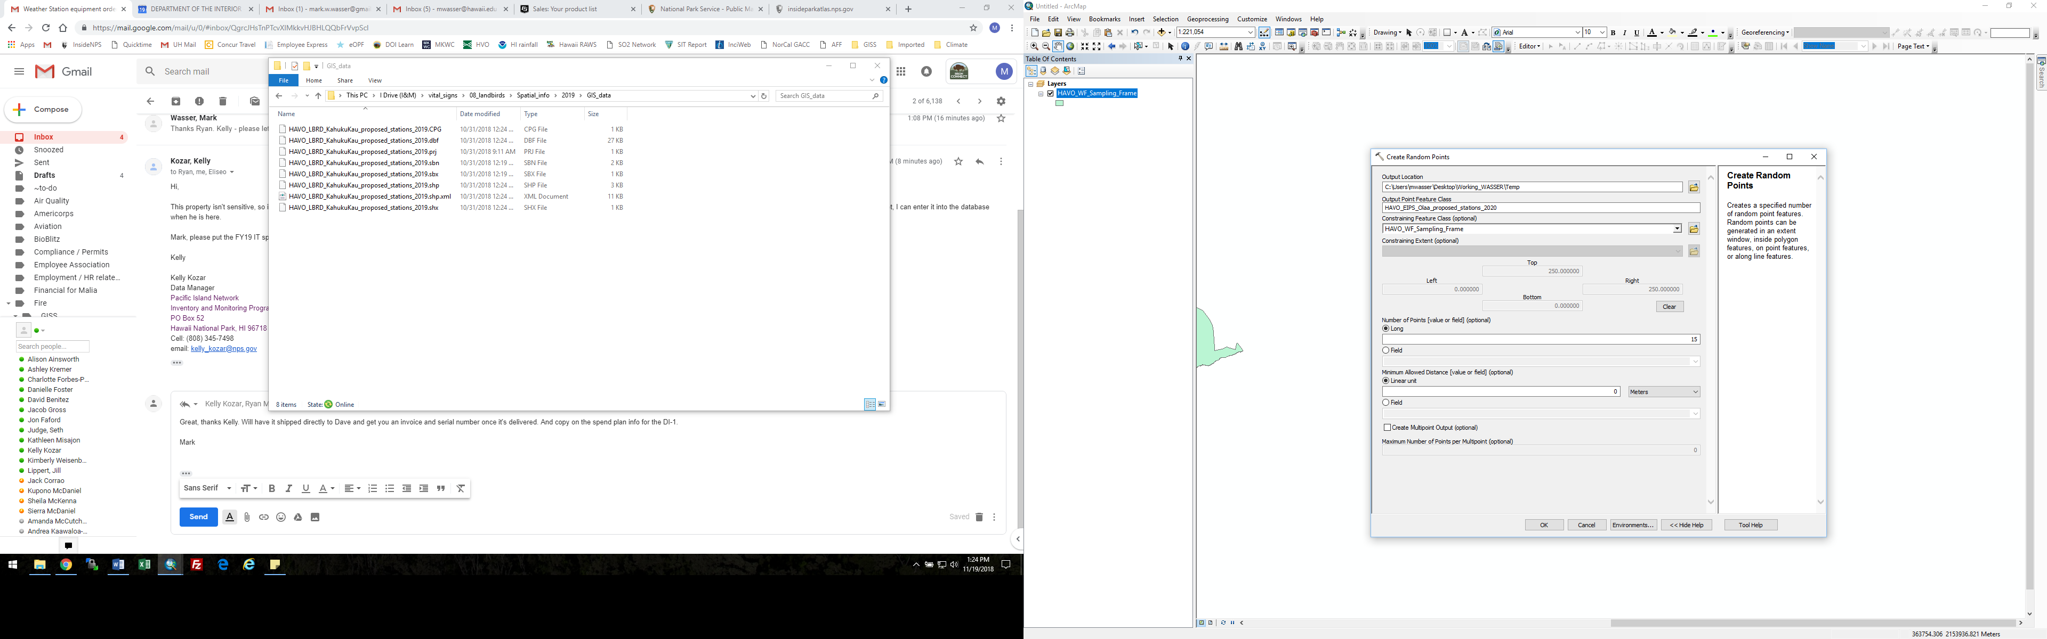

1. Use the Field Calculator to generate a set of random numbers for cells in the *Random* field. Within the Field Calculator, change the Parser type to Python and check the Show Codeblock box.   
   Type the following code in the Pre-Logic Script Code box:

import random

def rand():

return random.random()

Then type the following code in the Random = box:

rand()

Click OK.

*The rotational / alternate transect point list will be sorted in the following step by the random numbers just generated – this is done to randomize the transect order.*

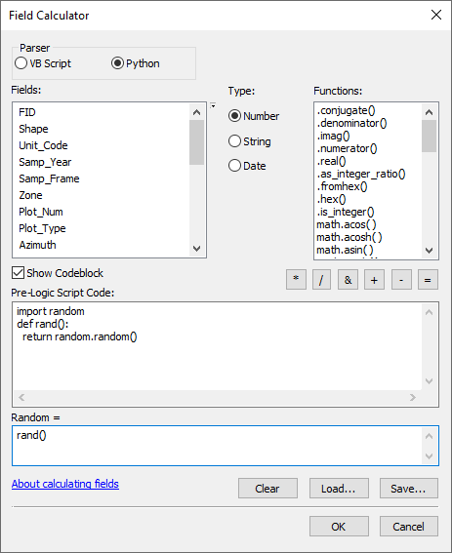

1. Run the Sort Tool (ArcToolbox 🡪 Data Management Tools 🡪 General 🡪 Sort). Specify your output dataset for the following location with the following naming convention

Location = \\inphavoim01\vital_signs\12_established_invasive_plant_species\

\Spatial_info\[YYYY]\[Park_Name]\GIS_Data\

Shapefile Name = [Park_Name]_EIPS_[Zone]_proposed_[YYYY]

Example name = HAVO_EIPS_Olaa_proposed_2020.shp

1. Open the newly created (sorted) shapefile in ArcMap®. Select the *Trans_Num* field and populate as appropriate. Rotational transects will have a two digit number (with an S behind each since these are the transect starts – i.e. 11S), and alternate transects will have and A prefix with a single number followed by an S (starting with A1S, A2S, etc.). Refer to the EIPS sampled sites SDE feature class to determine the numbers to assign rotational transects (start with the next number in the sequence for that sampling frame). Also populate the *Trans_Type* field with ‘Rotational’ or ‘Alternate’. Leave these fields blank for extra points at the bottom of the list. If a numbered start point need to be rejected during transect line generation (step 8), reassign the plot number of the rejected point to a blank point for the bottom of the list.
2. Assign random azimuths to each plot point. Open the attribute table and select the *Azimuth* field. Use the Field Calculator to generate a set of random numbers between 1 and 360 for cells in the *Azimuth* field. To do this, open the Field Calculator, change the Parser type to Python, and check the Show Codeblock box.   
   Type the following code in the Pre-Logic Script Code box:

import numpy

def random(min_val, max_val):

return numpy.random.randint(min_val,max_val)

Then type the following code in the Azimuth = box:

random(1,360)

Click OK. If there are issues running the Python code there is a good ESRI thread [here](https://community.esri.com/thread/96917).

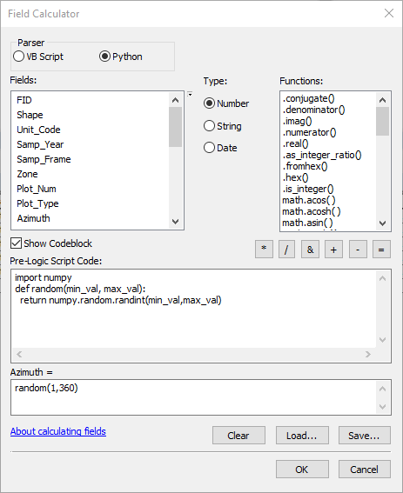

1. Draw transect polylines of appropriate length (see Table SOP 5.a.1 for transect lengths) in the directions of the assigned transect azimuths. If the transect reaches a buffered feature, passes through an area with a slope more than 70% (35°), or crosses another rotational transect from the same sample cycle before the full length is drawn, attempt to draw the transect line in the opposite direction (180° from the generated azimuth). If this is also unsuccessful, discard the transect and the start point, and follow the directions in step 6 to reassign the plot number of the rejected point to a blank point for the bottom of the list.

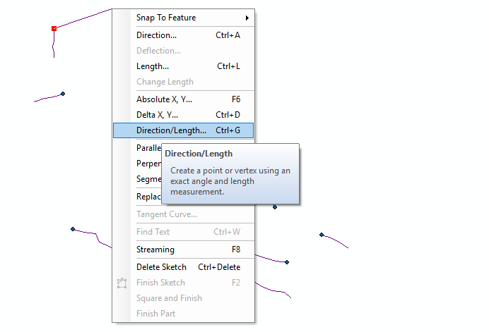

1. Place an end point at the terminus of the transect line. Only transect start and end points are generated. Plot start points are not generated, they are measured on the ground from the transect start point during sampling, and marked in the field as they are sampled.
2. Continue generating transects and plot end points from each random starting point until the appropriate number of transects per sampling frame including alternatives (Table SOP 5.a.1) have been selected. To ensure compatibility with PACN Landbirds Protocol (Camp et al. 2011) and Focal Terrestrial Plant Community Protocol (Ainsworth et al. 2011), consult with the respective project leads to verify that the new transects meet their protocol requirements. Once new transects have been ok’d, discard [delete] the remaining extra start points at the bottom of the randomly generated point list.
3. Populate attribute fields for the newly created end points. Copy all values from the corresponding start points except for the *Trans Num*, *Placement*, *Latitude*,and *Longitude* fields.For the *Trans* Num field, match transect numbers with corresponding start points, and use an E following the number to indicate transect ends. Use the value ‘End’ for the *Placement* field. Calculate geometry in GCS: WGS 1984 for the *Latitude* and *Longitude* fields.

Preparing Field Materials

Once all of the transects for a sampling cycle are generated, the GIS specialist should assist in preparing the location information for use by the field crew. This includes:

1. Print out lat/lon coordinates and azimuths for all transects.
2. Provide information on the proximity of transects to each other and nearby access points as well as the recommended order of sampling to maximize efficiency in the field.
3. Develop and print field maps displaying each transects location relative to the others’ and any landmarks that may aid field navigation.
4. Upload the points into Global Positioning System (GPS) units (see SOP #6 Downloading and Uploading Data from/to Garmin® GPS) along with any landmarks (roads, trails, streams, etc.) that may aid field navigation.

Literature Cited

Ainsworth, A., P. Berkowitz, J. D. Jacobi, R. K. Loh, and K. Kozar. 2011. Focal terrestrial plant communities monitoring protocol: Pacific Island Network. Natural Resource Report NPS/PACN/NRR—2011/410. National Park Service, Fort Collins, Colorado.

Camp, R. J., T. K. Pratt, C. Bailey, and D. Hu. 2011. Landbirds vital sign monitoring protocol – Pacific Island Network. Natural Resources Report NPS/PACN/NRR—2011/402. National Park Service, Fort Collins, Colorado.

Appendix SOP 5.a: Methodology Used for generation of initial fixed and rotational transects for first monitoring cycle, 2010-2014.

Procedures for Generating Fixed Transects and Initial Rotational Transects

Fixed transects were established along available legacy transects. Subsections of the legacy transects were selected as fixed transects using the “Random Point on Polylines” feature of the ET GeoWizard extension for ArcGIS®. Most areas did not have a sufficient number of legacy transects, and the remaining fixed transects were randomly generated in the same fashion as the rotational transects. Rotational transects for the initial sampling cycle were generated in ArcMap® 9.3 using the “Random Point Generation” tool within Hawth’s Tools. Generating new rotational and alternate transects for future sampling cycles follows a two-step procedure: (1) generate buffers and screen hazards and (2) generate transects. The GIS specialist has the necessary ArcMap® documents and base layers (park boundaries, streams, roads, etc.) to generate the required rotational transects for subsequent sampling cycles, as described below. To the greatest extent possible, this protocol will share transects with the PACN Landbirds (Camp et al. 2011) and Focal Terrestrial Plant Communities (Ainsworth et al. 2011) protocols. Table SOP 5.a.1 lists the required number of each type of transect for each frame.

**Table SOP 5.a.1.** Guidelines for transect generation for each sampling frame. At least three alternative transects should also be generated for each sampling frame in case a new location is rejected in the field.

| Park | Focal Community | Sampling Frame | Fixed Transects | Rotational Transects | Transect Length (m) | Plot Dimensions (m) | Legacy Available? |
| --- | --- | --- | --- | --- | --- | --- | --- |
| HAVO | Wet Forest | Nāhuku/ East Rift | 10 | 10 | 1000 | 5 x 20 | Yes |
| HAVO | Wet Forest | ‘Ōla‘a | 10 | 10 | 1000 | 5 x 20 | Yes |
| HAVO | Wet Forest | Kahuku | 15 | 15 | 250 | 5 x 10 | Yes |
| HAVO | Subalpine shrubland | Subalpine shrubland | 10 | 10 | 500 | 5 x 20 | No |
| HALE | Wet Forest | Wet forest | 10 | 10 | 1000 | 5 x 20 | Yes |
| HALE | Subalpine shrubland | Subalpine shrubland | 10 | 10 | 500 | 5 x 20 | No |
| KALA | Rocky Shoreline | Coastal Strand | 16 | 0 | Variable | 5 x 10 | No |
| KALA | Sandy Shoreline | Coastal Strand | 11 | 0 | Variable | 5 x 10 | No |
| NPSA | Wet Forest | Ta‘ū | 10 | 10 | 500 | 5 x 20 | Yes |
| AMME | Mangrove Forest | Mangrove Forest | 6 | 0 | Variable | 5 x 10 | Yes |

Generating Fixed Transects along Legacy Transects

Where possible, fixed transects were randomly established along legacy transects. If not all of the fixed transects could be placed along legacy transects, new transects as well as alternatives in case of rejection in the field were generated following the same procedures as for rotational transects. In most sampling frames, no more than one fixed transect was randomly placed along each legacy transect. Because legacy transects in NPSA and HALE are few in number but very long, in some cases more than one fixed transect was randomly placed along a legacy transect with a minimum 500 m buffer between fixed transects in those wet forest sampling frames. To generate fixed transects along existing legacy transects for the initial sampling cycle, the following procedure was used:

1. Using the “Random Points on Polylines” feature of the ET GeoWizards extension for ArcGIS® (9.3), a point was generated along the selected legacy transect.
2. From the point, the fixed transect was extended the appropriate length (Table SOP 5.a.1) along the legacy transect in a randomly chosen direction.

* If the legacy transect was too short to fit the entire fixed length in the first direction, the fixed transect was extended in the opposite direction.
* If the length of the fixed transect still did not fit after trying both directions and the legacy transect was long enough to accommodate the entire length, the point was adjusted in the appropriate distance to accommodate the length in the first direction.
* If a legacy transect was too short to contain the entire length of a fixed transect, the fixed length was extended past the end of the legacy transect in the first direction.
* Once established, the sample transect was oriented in the same direction as the legacy.

1. Transect numbers and X and Y Universal Transverse Mercator (UTM) coordinates were assigned for the start and end points of each transect.

Park Special Considerations: Exceptions to the guidelines above occurred. Given the small size of the mangrove forest sampling frame, the entire length of all legacy transects was used at AMME, and no rotational transects were/are used. At KALA, the shape and size of the coastal strand sampling frame as well as management concerns regarding spread of invasive species led to the exclusion of rotational transects and a stratified array of fixed transects. Fixed transects at KALA start 16 m in from the inland edge of the sampling frame and extend to within 16 m of the coastline. They are spaced every 200 m and, for those over the same substrate type, are parallel to one another. Given the difficulty of the terrain in HALE wet forest, all transects were required to have an endpoint near or cross an existing access points such as roads, trails, or existing legacy transects.